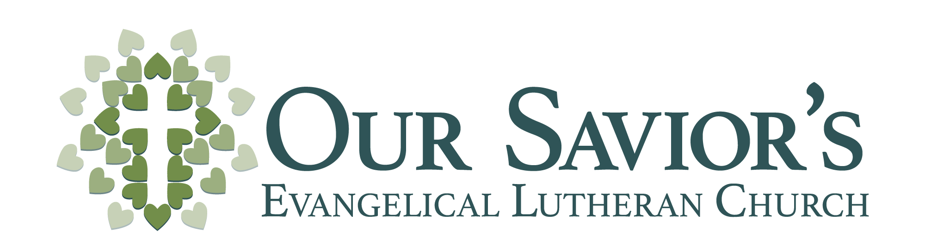

9th Sunday of Pentecost - August 2, 2020

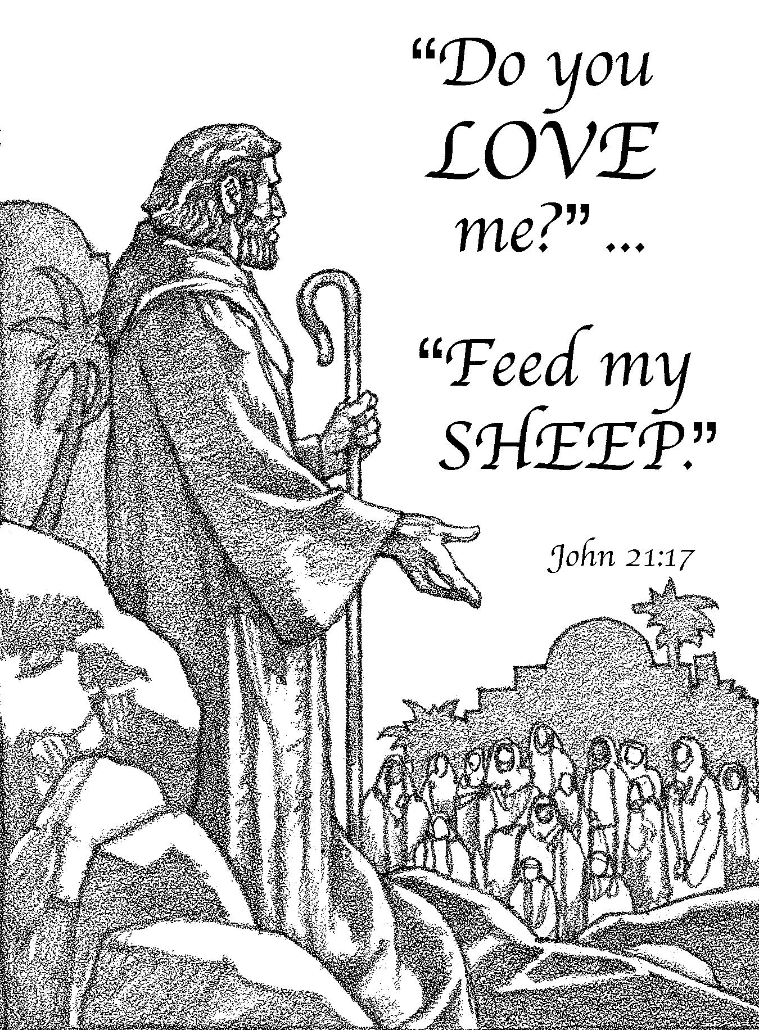
Opening Hymn – 545 v. 1,2 “Send, O Lord, your Holy Spirit”
Sing: ♫ Send, O Lord, your Holy Spirit
On your servants now, we pray;
Let them all be faithful shepherds
That no lamb is led astray.
Your pure teaching to proclaim,
To adore your holy name,
And to feed your lambs, dear Savior,
Make their aim and sole endeavor.

♫ You, O Lord yourself have called them
For your precious lambs to care;
But to prosper in their calling,
They the Spirit’s gifts must share.
Grant them wisdom from above;
Fill their hearts with holy love.
In their weakness, Lord be near them;
In their prayers, Good Shepherd, hear them.
Text: German hymn, 19th century; tr. Frederick W. Herzberger, 1859–1930, alt.

Service of the Word
M: The grace of our Lord Jesus Christ and the love of God and the fellowship of the Holy Spirit be with you.
C: And also with you.
M: We have come into the presence of God, who created us to love and serve him as his dear children. But we have disobeyed him and deserve only his wrath and punishment. Therefore, let us confess our sins to him and plead for his mercy.
C: Merciful Father in heaven, I am altogether sinful from birth. In countless ways I have sinned against you and do not deserve to be called your child. But trusting in Jesus, my Savior, I pray: Have mercy on me according to your unfailing love. Cleanse me from my sin, and take away my guilt.
M: God, our heavenly Father, has forgiven all your sins. By the perfect life and innocent death of our Lord Jesus Christ, he has removed your guilt forever. You are his own dear child. May God give you strength to live according to his will.
C: Amen.
M: In the peace of forgiveness, let us praise the Lord.
C: Oh, taste and see that the Lord is good. Blessed are they who take refuge in him. Your Word, O Lord, is eternal; it stands firm in the heavens. Your faithfulness continues forever.
Oh, taste and see that the Lord is good. Blessed are they who take refuge in him.
M: Almighty God, you have committed to your Church the task of making disciples of all nations. Enlighten with your wisdom those who teach and those who learn, that, rejoicing in the knowledge of your truth, they may worship and serve you from generation to generation, through Jesus Christ, your Son, our Lord, who lives and reigns with you and the Holy Spirit, one God, now and forever.
C: Amen.

Old Testament Lesson Deuteronomy 11:1-7, 16-21 (EHV)
Love the Lord your God and always carry out his requirements, his statutes, his ordinances, and his commandments. Know this today! I am not addressing your children, who have not known and seen all these things: the discipline of the Lord your God; his greatness, his strong hand, and his outstretched arm; his signs and his deeds that he performed in Egypt against Pharaoh king of Egypt and against all his land; what he did to the army of Egypt and its horses and chariots; how he caused the water of the Red Sea to flow over their heads when they pursued you; how the Lord has destroyed them to this day; what he did for you in the wilderness until you came to this place; what he did to Dathan and Abiram, the sons of Eliab son of Reuben; how the earth opened its mouth and swallowed them with their households, their tents, and every living thing that was at their feet, in the middle of all Israel. Know today it is your own eyes that have seen every deed that the Lord your God performed. Be careful, or your heart will be deceived and you will turn away and serve other gods and bow down to them. Then the anger of the Lord will burn against you, and he will close up the heavens. There will be no rain, the ground will not produce crops, and you will perish quickly from the good land that the Lord is giving you. Put these words of mine in your hearts and in your soul, and tie them on your wrists as signs and as symbols on your forehead. Teach them to your children by talking about them when you sit in your house and when you travel on the road, when you lie down and when you get up. Write them on the doorframes of your houses and on your gates, so that your days and the days of your children may be many on the land that the Lord promised to your fathers with an oath, as many as the days that the heavens remain over the earth.

Epistle Lesson II Timothy 3:14-17 (EHV)
As for you, continue in the things you have learned and about which you have become convinced. You know from whom you learned them 15 and that from infancy you have known the Holy Scriptures, which are able to make you wise for salvation through faith in Christ Jesus. 16 All Scripture is God breathed and is useful for teaching, for rebuking, for correcting, and for training in righteousness, 17 so that the man of God may be complete, well equipped for every good work.

Verse of the Day Proverbs 2:6 (NIV 84)
M: Alleluia! The Lord gives wisdom, and from his mouth come knowledge and understanding. Alleluia!

C: Alleluia! These words are written that we may believe that Jesus is the Christ, the Son of God. Alleluia!

Gospel Lesson Matthew 7:24-27 (EHV)
“Everyone who hears these words of mine and does them will be like a wise man who built his house on bedrock. 25 The rain came down, the rivers rose, and the winds blew and beat against that house. But it did not fall, because it was founded on bedrock. 26 Everyone who hears these words of mine but does not do them will be like a foolish man who built his house on sand. 27 The rain came down, the rivers rose, and the winds blew and beat against that house, and it fell—it was completely destroyed.”
This is the Gospel of our Lord.
C: Praise be to you, O Christ!

Hymn – 513 v. 1,2 “Lord Jesus Christ, the Children’s Friend”

SERMON John 21:15-19
When they had eaten breakfast, Jesus asked Simon Peter, “Simon, son of John, do you love me more than these?” “Yes, Lord,” he said, “you know that I care about you.” Jesus told him, “Feed my lambs.” A second time Jesus asked him, “Simon, son of John, do you love me?” He said, “Yes, Lord, you know that I care about you.” Jesus told him, “Be a shepherd for my sheep.” He asked him the third time, “Simon, son of John, do you care about me?” Peter was grieved because Jesus asked him the third time, “Do you care about me?” He answered, “Lord, you know all things. You know that I care about you.” “Feed my sheep,” Jesus said. “Amen, Amen, I tell you: When you were young, you dressed yourself and went wherever you wanted. But when you are old, you will stretch out your hands, and someone else will tie you and carry you where you do not want to go.” Jesus said this to indicate the kind of death by which Peter would glorify God. After saying this, he told him, “Follow me.”

Do You Love Me? Feed My Sheep!

Apostles’ Creed
I believe in God, the Father almighty, maker of heaven and earth.

I believe in Jesus Christ, his only Son, our Lord, who was conceived by the Holy Spirit, born of the virgin Mary, suffered under Pontius Pilate, was crucified, died, and was buried.
He descended into hell. The third day he rose again from the dead. He ascended into heaven and is seated at the right hand of God the Father almighty. From there he will come to judge the living and the dead.

I believe in the Holy Spirit, the holy Christian Church, the communion of saints, the forgiveness of sins, the resurrection of the body, and the life everlasting. Amen.

Teacher Installation

M: Our Lord and Savior Jesus Christ said to his Church: “All authority in heaven and on earth has been given to me. Therefore go and make disciples of all nations, baptizing them in the name of the Father and of the Son and of the Holy Spirit, and teaching them to obey everything I have commanded you. And surely I am with you always, to the very end of the age.”

A Christian school is one way we carry out our Lord’s command as we let children come to him and do not hinder them but rather nurture them with the life-giving Word of God. We do this trusting God’s promise: “Train and child in the way he should go, and when he is old he will not turn from it.”

Exhortation to the Teacher-elect
M: Dear brother in Christ, Our Savior’s Evangelical Lutheran Church has called you to serve as a teacher. You have been prepared for this ministry by careful instruction in the Word of God so that you carry out your duties in conformity with that Word.
As an ambassador of Christ, you are to teach the pure doctrine of God’s Word, to instruct the young in the way of salvation, and always to have in your heart the spiritual welfare of every soul under your care.
You are to devote yourself to the meditation and study of the Scriptures. You are to be an example to others in godliness and Christian living, putting no stumbling block in anyone’s path, so that the ministry will not be discredited.
You are to speak the truth in love, as the apostle Peter reminds us: “Love each other deeply, because love covers over a multitude of sins. If anyone speaks, he should do it as one speaking the very words of God. If anyone serves, he should do it with the strength God provides, so that in all things God may be praised through Jesus Christ. To him be the glory and the power for ever and ever.”
“Let the word of Christ dwell in you richly as you teach and admonish one another with all wisdom, and as you sing psalms, hymns and spiritual songs with gratitude in your hearts to God. And whatever you do, whether in word or deed, do it all in the name of the Lord Jesus, given thanks to God the Father through him.”
The ability to carry out this calling is not in us but comes alone from God, as St. Paul reminded the Corinthian Christians: “Not that we are competent in ourselves to claim anything for ourselves, but our competence comes from God.”
The Holy Spirit, who himself has called you to this ministry, will be with you.

Promises by the Teacher-elect
M: In keeping with the Word and will of the Lord, you are about to be commissioned into the ministry and installed as a teacher at Our Savior’s. I ask you in the presence of God and this congregation:
Are you fully determined to carry out this work according to the grace which God will give? I am.

Do you believe that the canonical books of the Old and New Testaments are the inspired Word of God and the only infallible rule of faith and practice? I do.

Do you accept the three Ecumenical Creeds--the Apostles’, the Nicene, and the Athanasian--as faithful testimonies to the truth of the Holy Scriptures, and do you reject all the errors which they condemn?
I do.

Do you solemnly promise that all your teaching will conform to the Holy Scriptures and the Lutheran Confessions? I do.

Will you give faithful witness to Christ in the world that God’s love may be known in all that you do and say? I will, and I ask God to help me.

Almighty God, who has given you the will to do these things, graciously give you the strength and compassion to perform them.

Exhortation to the congregation
M: Brothers and sisters in Christ, you have heard the solemn promise given by the teacher you have called. I urge you, therefore, to receive him with joy and to keep in mind always what the Word of God expects of you as members of this congregation:
- Work together with him for our Lord’s kingdom so that by your works of service the body of Christ might be built up.
- Help him by your word and example in teaching the young, remembering how the Scriptures urge you to bring up your children in the training and instruction of the Lord.
- Pray for him continually, that his ministry among you may be greatly blessed and that he may have a cheerful spirit in all his duties.
- Provide also for his physical needs, for the Lord says, “The worker deserves his wages.”
- Honor and love him, as the apostle Peter urges, “Live in harmony with one another; be sympathetic, love as brothers, be compassionate and humble.”

Promise by the congregation
M: I now ask you in the presence of God:
Are you willing to receive him as a servant of Christ? Will you show him love and honor and support him with your gifts and prayer?
If so, answer: we will and we ask God to help us.
C: We will, and we ask God to help us.
M: The almighty and merciful God strengthen and assist you always to keep your promises.

Addressing the students
M: Students of Our Savior’s here today, Jesus our Savior has promised eternal life to those who trust in him. Show your love to Jesus by cheerfully obeying your teacher, so that you benefit from his instruction, especially as he teaches you God’s saving Word. Give him honor and respect, so that his work will be a joy for him and an eternal blessing to you.

The teacher-elect kneels

Installation and Commissioning
M: Nathan Lemke, I commission you as a minister of the Church and install you as a teacher at Our Savior’s Lutheran School in the name of the Father and of the Son and of the Holy Spirit.
May the Lord pour out on you his Holy Spirit for the work committed to you, that you may faithfully proclaim the gospel.

Let us pray…
Almighty God, fountain of all wisdom, we praise and thank you for your goodness in giving us a Lutheran Elementary School. Continue to bless our labors here so that your Word may dwell richly in us and in our children and that your name may be glorified. Give the Holy Spirit to Mr. Nathan Lemke, and equip him with heavenly wisdom and strength, that he may lead our children to you and, despite any discouragements, faithfully carry out the duties of his calling. Move our students to godliness and obedience, and cause them to grow through their instruction in your Word so that they may service you throughout their lives and finally inherit eternal life. Help us at all times to regard our teacher as one whom you have sent so that we support him in his ministry and pray and work for the welfare of our school. Hear us for Jesus’ sake.
C: Amen

M: Go, then, take up the work to which you have been called.
The Lord bless you and make you a blessing to many, that you may bear fruit and that your fruit may remain to eternal life.

Hymn – 508 “Gracious Savior, Gentle Shepherd”

Sing: ♫ Gracious Savior, gentle Shepherd,
Children all are dear to you;
May your loving arms enfold them
In your care their whole life through.
Gently tend and safely keep them
In your mercy strong and true.

Meditate: Tender Shepherd, never leave them,
Never let them go astray;
By your warning love directed,
May they walk the narrow way.
Thus direct them, thus defend them
Lest they fall an easy prey.

Sing: ♫ By your holy Word instruct them;
Fill their minds with heav’nly light.
By your pow’rful grace convince them
Always to approve what’s right.
Let them feel your yoke is easy;
Let them find your burden light.

Meditate: Taught to love the holy praises
Which on earth your children sing,
With their lips and hearts, sincerely,
Glad thank off’rings may they bring,
Then with all the saints in glory
Join to praise their Lord and King.
Text: Jane E. Leeson, 1809–81, abr., adapt., alt.

CLOSING PRAYER & BLESSING
M: …through Jesus Christ, our Lord, who lives and reigns with you and the Holy Spirit, one God, now and forever.
C: Amen

M: Brothers and sisters, go in peace. Live in harmony with one another. Serve the Lord with gladness.
The Lord bless you and keep you. The Lord make his face shine on you and be gracious to you. The Lord look on you with favor and give you peace.
C: Amen.

CLOSING HYMN —293 “God’s Word Is Our Great Heritage”

Sing: ♫ God’s Word is our great heritage
And shall be ours forever;
To spread its light from age to age
Shall be our chief endeavor.
Through life it guides our way;
In death it is our stay.
Lord, grant, while worlds endure,
We keep its teachings pure
Throughout all generations.
Text: Nikolai F. S. Grundtvig, 1783–1872; tr. Ole G. Belsheim, 1861–1925.

----------------------------------

Welcome Home to Worship!
Please wait to be ushered out from the back –
help us reduce congestion at the doors.
Please take bulletins with you or recycle them in the bin.

Permission to reprint hymns in this service obtained from ONE LICENSE
with license #A-716671. All rights reserved.

