

Saints Triumphant Sunday ~ November 12 & 15, 2020

Opening Hymn –206 v. 1 “Wake, Awake, for Night Is Flying”
“Wake, awake, for night is flying,” The watchmen on the heights are crying,
“Awake, Jerusalem, arise!”
Midnight hears the welcome voices And at the thrilling cry rejoices:
“Oh, where are all you virgins wise?
The Bridegroom comes--awake! Your lamps with gladness take! Alleluia!
With bridal care yourselves prepare To meet the Bridegroom who is near.”
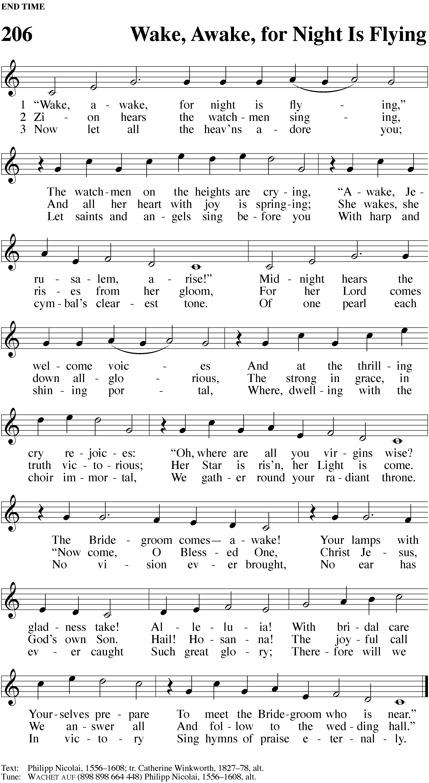

Common Service
M: In the name of the Father and of the Son and of the Holy Spirit.
C: Amen.
M: Beloved in the Lord: let us draw near with a true heart and confess our sins to God our Father, asking him in the name of our Lord Jesus Christ to grant us forgiveness.
C: Holy and merciful Father, I confess that I am by nature sinful and that I have disobeyed you in my thoughts, words, and actions. I have done what is evil and failed to do what is good. For this I deserve your punishment both now and in eternity. But I am truly sorry for my sins, and trusting in my Savior Jesus Christ, I pray: Lord, have mercy on me, a sinner.
M: God, our heavenly Father, has been merciful to us and has given his only Son to be the atoning sacrifice for our sins. Therefore, as a called servant of Christ and by his authority, I forgive you all your sins in the name of the Father and of the Son (+) and of the Holy Spirit.
C: Amen.
M: Let us pray: Amighty God and Savior, you have set the final day and hour when we shall be delivered from this world of sin and death. Keep us ever watchful for the coming of your Son, so that we may sit with him and all your holy ones at the marriage feast in heaven. We praise him who prepared it for us: Jesus Christ, your Son, our Lord, who lives and reigns with you and the Holy Spirit, one God, now and forever.
C: Amen.

First Lesson Isaiah 52:1-6 (EHV)
Our God is the Lord of history. He subjugates nations and raises them up as he wills. When he acts on behalf of his people, he does so out of pure grace.
Wake, awake! Clothe yourself with strength, O Zion. Put on your beautiful garments, Jerusalem, you holy city, for never again will the uncircumcised and the unclean enter you. 2 Shake off the dust. Get up and take your seat, Jerusalem. Loosen the chains from your neck, you captive daughter of Zion. 3 Yes, this is what the Lord says. You were sold for nothing, and you will be redeemed without money. 4 Yes, this is what the Lord God says. In the beginning, my people went down to Egypt to stay there for a while. Later Assyria oppressed them without cause. 5 Now what do I have here? declares the Lord. Indeed, my people have been taken away for nothing. Their rulers howl with mockery, declares the Lord. My name is continually despised all day. 6 Therefore my people will know my name. So on that day they will know that I am the one— the one who is saying, “Here I am!”
Second Lesson I Thessalonians 4:13-18 (EHV)
Jesus’ resurrection is the sure foundation of our confidence that those who have “fallen asleep in him” will join in the great resurrection of the dead on the Last Day. All believers will be caught up together to enjoy an eternal communion with the Lord. “Therefore, encourage each other with these words.”
We do not want you to be uninformed, brothers, about those who have fallen asleep, so that you do not grieve in the same way as the others, who have no hope. 14 Indeed, if we believe that Jesus died and rose again, then in the same way we also believe that God will bring with him those who have fallen asleep through Jesus. 15 In fact, we tell you this by the word of the Lord: We who are alive and left until the coming of the Lord will certainly not go on ahead of those who have fallen asleep. 16 For the Lord himself will come down from heaven with a loud command, with the voice of an archangel, and with the trumpet call of God, and the dead in Christ will rise first. 17 Then we who are alive, who are left, will be caught up in the clouds together with them, to meet the Lord in the air. And so we will always be with the Lord. 18 Therefore, encourage one another with these words.

Verse of the Day Revelation 7:15 (NIV 84)
M: Alleluia! They are before the throne of God and serve him day and night in his temple. Alleluia!
C: Alleluia! These words are written that we may believe that Jesus is the Christ, the Son of God. Alleluia!

Gospel Lesson Matthew 25: 1-13 (EHV)
The parable of the ten virgins calls us to constant vigilance, since the day and hour of our Lord’s judgment is not known.
At that time the kingdom of heaven will be like ten virgins who took their lamps and went out to meet the bridegroom. 2 Five of them were foolish, and five were wise. 3 When the foolish ones took their lamps, they did not take any oil with them; 4 but the wise took oil in their containers with their lamps. 5 While the bridegroom was delayed, they all became drowsy and fell asleep. 6 But at midnight there was a shout, ‘Look, the bridegroom! Come out to meet him!’ 7 Then all those virgins got up and trimmed their lamps. 8 The foolish ones said to the wise, ‘Give us some of your oil because our lamps are going out.’ 9 But the wise answered, ‘No, there may not be enough for us and for you. Instead, go to those who sell oil and buy some for yourselves.’ 10 But while they were away buying oil, the bridegroom came. Those who were ready went in with him to the wedding banquet, and the door was shut. 11 Later, the other virgins also came and said, ‘Lord, Lord, let us in.’ 12 But he answered, ‘Amen I tell you: I do not know you.’ 13 Therefore, keep watch, because you do not know the day or the hour. This is the gospel of our Lord.
C: Praise be to you, O Christ!

Roll Call of Saints Gone Ahead
M: Listen, I tell you a mystery: We will not all sleep, but we will all be changed—in a flash, in the twinkling of an eye, at the last trumpet.
C: For the trumpet will sound, the dead will be raised imperishable, and we will be changed.
(1 Corinthians 15:51-52)
Arthur Wayne Schulrud
May 11, 1931 – November 23, 2019
88 years, 6 months, 12 days of grace

M: Be faithful, even to the point of death.
C: And I will give you the crown of life. (Revelation 2:10)
Valeria Anna Baumann
December 28, 1925 – April 21, 2020
94 years, 3 months, 5 days of grace

M: In my Father’s house are many rooms; if it were not so, I would have told you.
C: I am going there to prepare a place for you. (John 14:2)
Orville Evanson
March 13, 1919 – June 14, 2020
101 years, 3 months, 1 day of grace

M: Since, then, you have been raised with Christ, set your hearts on things above, where Christ is seated at the right hand of God.
C: Set your minds on things above, not on earthly things. (Colossians 3:1-2)
Susan Kathleen Bishop
January 9, 1965 – September 15, 2020
55 years, 8 months, 6 days of grace

M: I know that my Redeemer lives, and that in the end he will stand upon the earth.
C: And after my skin has been destroyed, yet in my flesh I will see God. (Job 19:25-26)
John L. Durkee
October 10, 1942 – October 21, 2020
78 years, 11 days of grace

M: The LORD gave and the LORD has taken away;
C: may the name of the LORD be praised.” (Job 1:21)
Walter Emil Braatz
January 17, 1925 – October 22, 2020
95 years, 9 months, 4 days of grace

M: With long life will I satisfy him
C: and show him my salvation. (Psalm 91:16)
Shirley Beilke
November 5, 1928 – November 4, 2020
91 years, 11 months, 29 days of grace

M: The LORD is good to those whose hope is in him, to the one who seeks him;
C: it is good to wait quietly for the salvation of the LORD. (Lamentations 3:25-26)
For all the men and women who died in the saving faith
while serving country and local communities +
M: For the LORD will ransom Jacob
C: and redeem them from the hand of those stronger than they. (Jeremiah 31:11)
M: I am resurrection and the life. He who believes in me will live, even though he dies;
C: And whoever lives and believes in me will never die. (John 11:25-26)

Hymn – 325 “How Blest Are They Who Hear God’s Word”

Sing: How blest are they who hear God’s Word And keep and heed what they have heard!
They daily grow in wisdom.
Their light shines brighter day by day, And while they tread life’s weary way,
They have the oil of gladness To soothe their pain and sadness.

Meditate: God’s Word a treasure is to me, Through sorrow’s night by sun shall be,
The shield of faith in battle.
The Father’s hand has written there My title as his child and heir,
“The kingdom’s yours forever.” That promise fails me never.

Sing: Today I am my Savior’s guest; My soul is here so richly blest,
The bread of life receiving.
Oh, may thereby my faith prevail So that its fruits may never fail
Till my account is given Before God’s throne in heaven!
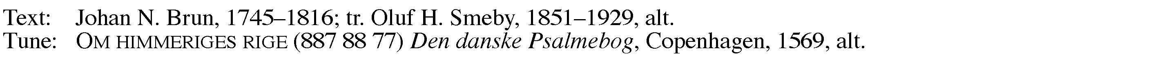

SERMON: Don’t Miss It! Matthew 25: 1-13
A pastor’s balancing act with Scripture is always to say the full message of God in any given text, but not to say more than God intended. Conservative Christians, and conservative Christian pastors, need to guard themselves against overstating the case.
A case in point: we have a commandment, “Remember the Sabbath Day by keeping it holy.” In the past, some have stated that honoring God on the Sabbath meant sitting in the living room staring at each other—doing nothing that could resemble work or fun. By healing people on a Sabbath day, by harvesting grain on a Sabbath, and contradicting the Pharisees’ quarrels with that, Jesus made clear that setting God as a priority never meant that the worship day required that we do absolutely nothing else on that day. To say so is an overstatement of what the Scriptures are teaching.
Overstating the case is a special issue in regard to parables. Most parables of Jesus have only one point to get across, but the details of a parable can get us off in a direction that Jesus never intended.
For example, our parable today is not an evangelism parable. It’s not about the relationship between the wise and the foolish virgins. Some have criticized the wise virgins as “callous” in sending the others off to get oil for themselves. Why didn’t they share? Why didn’t they generously warn the others ahead of time? There are plenty of other statements and parables of Christ about how we share the Word, about how we show love to others. That’s not the point of this parable.
Jesus’ intention is to illustrate that when Judgment comes, some will not be prepared. And that’s their fault. It’s a warning to me, for myself alone, to be ready. “Therefore, keep watch, because you do not know the day or the hour.” Don’t miss it! Let’s take to heart Jesus’ message to be ready.
And let’s not be too harsh in our criticisms. For, to be fair, both groups of virgins wanted to be at the wedding feast. Neither group is about to deliberately turn their backs on the invitation to the joyful occasion.
In a biblical context, we are often invited to a wedding feast. Revelation 19 urges, “Let us rejoice…because the wedding of the Lamb has come. His bride has made herself ready, and she was given bright, clean, fine linen to wear. (In fact, the fine linen is the “not guilty” verdicts pronounced on the saints.)” (vv 7-9). The foolish virgins are not atheists who have pointedly and repeatedly thumbed their noses at God. They wanted to be there too. They just weren’t ready.
A quick word about wedding customs of the time might illustrate why they weren’t ready. As typical in the Mideast, there was knowledge and consent on the part of the couple, but there were wheelings and dealings involved also. When the agreement on dowry was reached, an engagement document was formally signed by all parties. But the wedding was not held until the agreements were paid in full. Typically, from engagement to marriage would be up to a year.
But the engagement ended, and the wedding took place, as soon as the financial arrangements were fulfilled. It could be a month; it could be seven months—hard to say. And it was the father of the groom who made the determination—not the father of the bride. The bride, and her bridesmaids, had to be ready at any day. Typically, a bride would have her veil, her lamp, her oil, and a special piece of fabric called a “Chuppah” on a shelf ready to grab and go. The bridesmaids only had to have lamps and oil, but still had to be ready because they wouldn’t have advance notice. Were you wise enough to keep checking your supplies? Did you ensure that you didn’t use that oil on a different night, or make sure you replaced it? If there were foolish virgins, it wasn’t because they didn’t want to be there or had forgotten about the wedding and its feast.
In fact, when told “there may not be enough for us and for you. Instead, go to those who sell oil and buy some for yourselves,” they didn’t sit around pouting about it. They went to get what they needed. And they were successful! In the middle of the night they found a merchant who was willing to get out of bed to sell them some oil. The problem wasn’t a disregard of the invitation or disrespect to the inviter, it’s that they thought they had time that they just didn’t have.
How do we get caught up in similar flawed thinking? Both of my parents are alive and in their mid-nineties. Both my grandmas lived into their nineties. There must be some long-life genes in our families. I could say that I wouldn’t need to get right with God for another 25-30 years.
You would rightly advise me not to wait, because I said nothing about my grandfathers’ length of life, did I? And there’s no predicting car accidents or other fatal incidents.
Plus, from a Christian perspective, you would remind me of all the parables Jesus told about watching and being prepared for his return. There were long ones and short ones and variations that Jesus told to different groups at different times. It was a theme he came back to on many occasions. This is but one of many warnings. Don’t miss it because you think you have time. That’s what got the foolish ones in trouble.
But even the wise virgins had some trouble. Both groups wanted to be there. Both groups almost missed it. “While the bridegroom was delayed, they all became drowsy and fell asleep.” The wise were just as sleepy as the foolish ones.
The bridegroom was delayed. Don’t we sometimes get to thinking that? It’s been over 2000 years since Jesus lived on this earth. The unbelieving world around us is glad to remind us of that. St. Peter wrote, “First, know this: In the last days scoffers will come with their mocking…. They will say, “Where is this promised coming of his? For from the time that our fathers fell asleep, all things continue as they have from the beginning of the creation,” (II Peter 3:3,4).
Understand that what I’m about to say is a thought provoker, not a biblical teaching.
So, we’re about 2000 years from Jesus’ life, death, resurrection and ascension. Is Jesus late yet?
Go to the other side of the timeline. 2000 years before Christ is the approximate time of Abraham. Abraham was given the promise of the Savior from his family line.
But the same promise was extended through Noah to his son Shem, what, another 2000 years before Abraham? How many years back from there to Adam and Eve who were given the first promise of the Savior? Their sin had set into motion the need for a Savior, and upon his timetable, God sent his Son into the world to redeem the world. 4-6 thousand years from the time of the first promise till Bethlehem’s stable; do we have the right to complain that Jesus is late in coming this second time?
That’s not an excuse to get complacent. It’s more just a thought to remind us that God’s timetable is not ours.
Our Meditations devotions this week have focused on Paul’s chapter 2 of Romans, and the specific encouragement: “Do you have so little regard for his rich kindness, his restraint, and his patience, that you ignore the fact that the purpose of God’s kindness is to lead you to repentance,” (v 4)? Whether one day or another thousand years, don’t get sleepy on God.
How does it happen to us?
Every week the service is the same! OK, there’s some variation, but overall couldn’t we, at any time, put our minds on autopilot, start with everyone else and come out on the other end of the service without thinking too hard?
Or isn’t it that the message is the same every week? We’re still talking about sin and about Jesus, just like always! Could you drop out for a couple years, come back and find it the same? I bet you could. You might be surprised that suddenly there’s a different pastor in the pulpit than you remember, but he’s on message.
Thank God that it is so! We need that kick in the pants because spiritual drowsiness and apathy angers God. If we shortchange our devotion time, we need to be warned that faith comes from hearing the message—and a lack of faith comes from a lack of hearing (Romans 10)! Not without reason did God command us, “Let us not give up meeting together, as some are in the habit of doing,” (Hebrews 12:25). Online or in person, maybe we need that nudge. And we haven’t yet gotten beyond the 3rd commandment! In what ways will the rest of them show us our sins?
But thank God that the same old message of Jesus Christ is repeated weekly as well. We are refreshed with every reminder that “He is the atoning sacrifice for our sins, and not only for ours but also for the whole world,” (I John 2:2). I can’t blame you if my sermons sometimes make you drowsy, but don’t miss the glorious message of forgiveness!
Both the sleepy wise and sleepy foolish virgins almost missed out. But one group was ready and the other was not.
It should be pointed out that the wise virgins didn’t have anything to do with the banquet. They didn’t prepare the food. They didn’t decorate the hall. They didn’t send the invitations. They didn’t pay for the party. They just had to go in. “The bridegroom came. Those who were ready went in with him to the wedding banquet, and the door was shut.”
Just that way, you and I enjoy the wedding banquet of the Lamb of God. We don’t prepare it. We don’t pay for it. We don’t save ourselves. We go in if we are ready through faith in Christ.
The foolish tried to get themselves in. “Later, the other virgins also came and said, ‘Lord, Lord, let us in.’ But he answered, ‘Amen I tell you: I do not know you’.” They begged to be let in. On another occasion Jesus spoke of those who would try to argue their way in, “Many will say to me on that day, ‘Lord, Lord, did we not prophesy in your name and drive out demons in your name and perform many miracles in your name?’ Then I will tell them plainly, ‘I never knew you. Depart from me, you evildoers,” (Matthew 7:22,23). Begging or Arguing isn’t going to do it. Scripture is fairly blunt on this. Disconnected from Christ is disconnected—even if you know his name. Too late is too late—even if you know the address.
There’s not enough context to know why the parable’s bridegroom wasn’t going to open the door. Why was too late, too late for this feast? We don’t know. It just was.
This we do know: Sin and forgiveness is determining factors for heaven. Repent, as God urges. Believe, as he expects. Watch, as he warns. Christ has opened the door to you through his Word, today. Be ready. Stay ready. Don’t miss it! AMEN

Responsive PRAYER OF THE CHURCH
M: Jesus Christ, King of Glory, you came great lowliness once to bear our sins, to suffer our hell, and to die our death.
C: We thank you for your promise to come again.
M: When you first came, you accomplished the Father’s will to guarantee our forgiveness.
C: When you come again, we trust your promise to take us to heavenly mansions which you are preparing for all believers.
M: We pray for those today who have been reminded by the death of a loved one that life here is not permanent.
C: Comfort their hearts with the confidence that all who believe in you will rise to eternal life.
M: Keep our hearts and minds focused on you and your will for us, that we never become spiritually drowsy nor complacent.
C: Light our lamps of faith, O Spirit, and keep them burning in the darkness of this world.
M: If there are some with us today in body or in spirit, but have allowed time to separate themselves from you, give an eagerness to return to worship.
C: As each of us hears your Word, bring us a deeper desire to maintain our connection with you. and may our diligence towards your Word also ring out as a witness to all around us that there is something to prepare for--a Judgment!
M: We know, O Father, that your will is that all people may share the glorious privilege of knowing your in truth and accepting you by faith.
C: Fill us with the Holy Spirit that we become more diligent and skillful in bearing witness to your salvation.
M: Further, we pray, hear the needs of all your servants as they cry out to you.
C: When buffeted by trouble, sickness, want or care, give them peace of soul, and aid them according to your will.
M: Therefore, O Christ, we bring these people before you…
Personal prayers and petitions may be spoken
M: Enable us all to heed the call to watch and prepare for your coming. Until that day when you grant our petitions directly, we pray now as you taught us...
C: Our Father, who art in heaven, hallowed be thy name, thy kingdom come, thy will be done on earth as it is in heaven. Give us this day our daily bread; and forgive us our trespasses, as we forgive those who trespass against us; and lead us not into temptation, but deliver us from evil. For thine is the kingdom and the power and the glory forever and ever. Amen.

THE SACRAMENT
M: The Lord be with you.
C: And also with you.
M: Lift up your hearts.
C: We lift them up unto the Lord.
M: Let us give thanks to the Lord, our God.
C: It is good and right so to do.
M: It is truly good and right that we should at all times and in all places give you thanks, O Lord, holy Father, almighty and everlasting God, through Jesus Christ, our Lord, who preserves his Church to the end of time when he will come again as king to judge all people and take his own to glory. Therefore, with all the saints on earth and hosts of heaven, we praise your holy name and join their glorious song:
C: Holy, holy, holy Lord God of heavenly hosts: heav’n and earth are full of your glory. Hosanna in the highest. Blessed is he who comes in the name of the Lord. Hosanna in the highest.
M: Our Lord Jesus Christ, on the night he was betrayed, took bread; and when he had given thanks, he broke it and gave it to his disciples, saying, “Take and eat; this is my body, which is given for you. Do this in remembrance of me.”
Then he took the cup, gave thanks, and gave it to them, saying, “Drink from it, all of you; this is my blood of the new covenant, which is poured out for you for the forgiveness of sins. Do this, whenever you drink it, in remembrance of me.”
The peace of the Lord be with you always.
C: Amen. O Christ, Lamb of God, you take away the sin of the world; have mercy on us and grant us your peace. Amen.

DISTRIBUTION HYMN – 10 “The Bridegroom Soon Will Call Us”
Sing: The Bridegroom soon will call us; Shake off your drowsy sleep!
Lest carelessness befall us, A watchful vigil keep!
May all our lamps be burning With oil enough and more
That we, with him returning, May find an open door!

Meditate: There shall we see in glory Our dear Redeemer’s face;
The long awaited story Of heav’nly joy take place:
The patriarchs shall meet us, The prophets’ holy band;
Apostles, martyrs greet us In that celestial land.

Meditate: There God shall from all evil Forever make us free,
From sin and from the devil, From all adversity,
From sickness, pain, and sadness, From troubles, cares, and fears,
And grant us heav’nly gladness And wipe away our tears.

Sing: In that fair home shall never Be silent music’s voice;
With hearts and lips forever We shall in God rejoice,
While angel hosts are raising With saints form great to least
A mighty hymn for praising The giver of the feast.
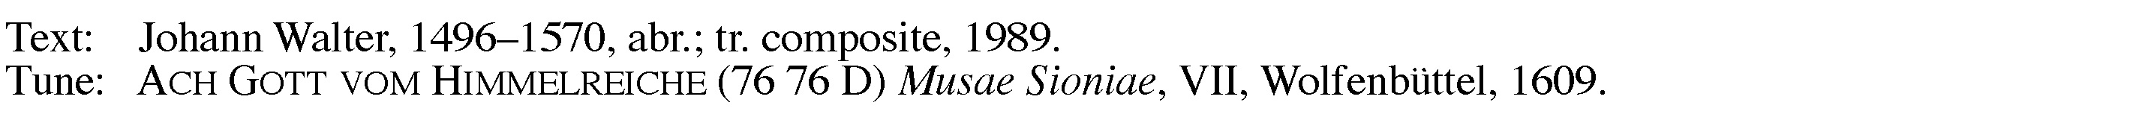

THANKSGIVING
C: Lord, now you let your servant depart in peace according to your word. For my eyes have seen your salvation, which you have prepared before the face of all people, a light to lighten the Gentiles and the glory of your people Israel.
M: Prayer … now and forever.
C: Amen.
M: The Lord bless you and keep you.
The Lord make his face shine on you and be gracious to you.
The Lord look on you with favor and (+) give you peace.
C: Amen.
CLOSING HYMN — 596 “Let Me Be Yours Forever”
Sing: Let me be yours forever, My faithful God and Lord;
Let me forsake you never Nor wander from your Word.
Lord, do not let me waver But give me steadfastness,
And for such grace and favor Your holy name I’ll bless.

Lord Jesus, my salvation, My light, my life divine,
My only consolation, To you I all resign,
For you have dearly bought me With blood and bitter pain.
Let me, since you have sought me, Eternal life obtain.

O gracious Holy Spirit, My comforter and guide,
Grant that in Jesus’ merit I always may confide,
Him to the end confessing Whom I have known by faith.
Give me your constant blessing And grant a Christian death.
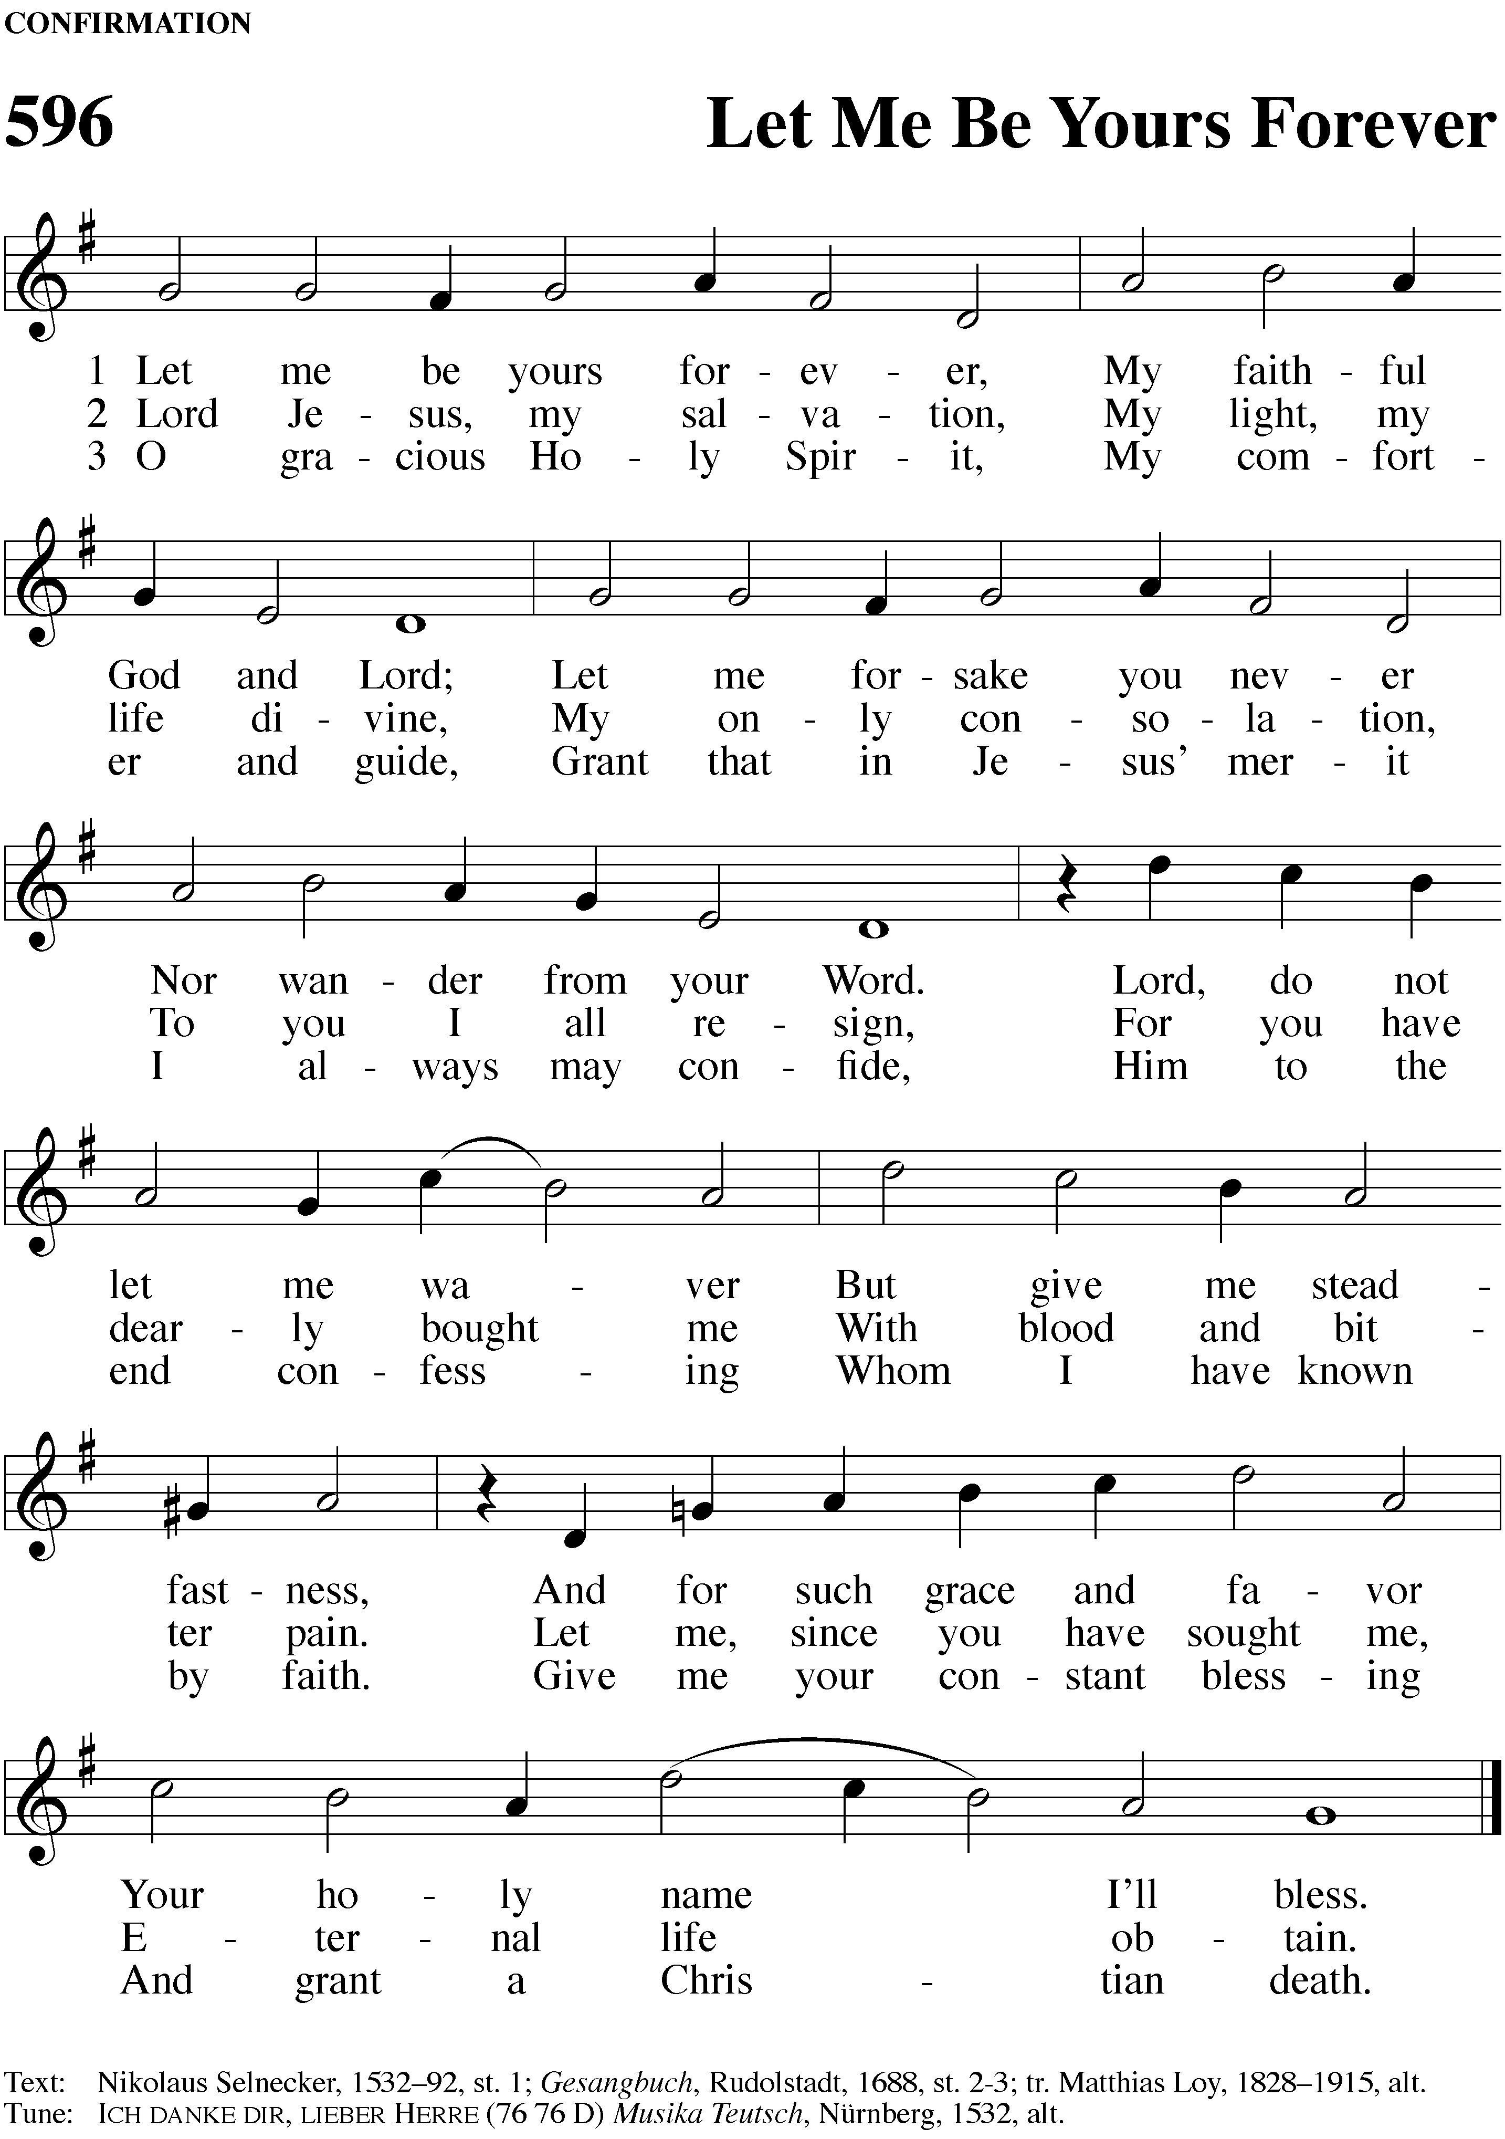

------------------------------------------------------------------------------------------------------------

NOTES and NEWS

Saints Triumphant Sunday We extend a warm welcome and our sincere sympathies to all who join us to remember our members who have fallen asleep in Jesus and were taken to heavenly glory in the past year.

Door Offering: Lutheran Military Support Group This WELS/ELS organization is dedicated to assisting the military members of our churches, our veterans as well as those actively serving, especially during their time away from home and when their return is challenged by injuries.

Thanksgiving Eve Worship Please join us for a special Thanksgiving Eve worship service on Wednesday, Nov. 25 at 6:30 PM
Memorials
We thank Len and Loris Becker for their gift to the Vision fund given in memory of John Durkee.
We thank Angie Marquis for her gift given in memory of John Durkee.
We thank Geneva Weith for her gift to the Vision fund given in memory of Walter Braatz.
Blessed be their memories. Thanks be to God for the love which led to these gifts.

This Week’s Opportunities for Growing in Christ

Sunday 11/15  -Saints Triumphant  -LMSG Door Offering | 8:00 AM  9:15 AM  10:30 AM | Worship with Communion  Bible Class  Worship
Tuesday | 6:00 PM | Bible Information Class
Wednesday | 4:00 PM | Catechism
Thursday | 6:30 PM | Worship
Sunday 11/22  -Christmas Family Door Offering | 8:00 AM  9:15 AM  10:30 AM | Worship  Bible Class  Worship



Our Stewardship of God’s Gifts: Nov. 1 & 8, 2020
Weekly Vision Debt Red Memorials ABC Childcare
$1,040.00 $75.00 $75.00 $10.00 $2,700.00
Permission to reprint hymns in this service obtained from ONE LICENSE with license #A-716671. All rights reserved.

