

Midweek Advent ~ December 2, 2020

Opening Hymn – CW 29
♫ Lo, he comes with clouds descending,
Once for ev’ry sinner slain.
Thousand, thousand saints attending
Swell the triumph of his train.
Alleluia! Alleluia!
Christ reveals his endless reign.

Invocation (sung)
Pastor: In the name of the Father...
Congregation: Alleluia! Alleluia!
Pastor: In the name of the Son…
Congregation: Alleluia! Alleluia!
P: In the name of the Spirit…
C: Alleluia and Amen!

Confession (sung)
P: We know that we are the reason you first came; Lord, have mercy.
C: Lord, have mercy.
P: In ignorance and in stubborn sin we had nailed you to the tree;
Christ, have mercy.
C: Christ, have mercy.
P: Prompted by your Spirit we acknowledge our sin and plead for your mercy; Lord, have mercy.
C: Lord, have mercy.

Absolution
P: Because of his great love for us, Christ has redeemed us.
As a fellow forgiven child of God, and called servant of Christ, I proclaim his grace to you. Rejoice in his salvation!
C: ♫ Alleluia! Alleluia! Jesus is our Lord and King!

Prayer of the Day
Pastor (sung psalm style):
Lord Jesus, when you as-`cend-ed,
Angels assured your disciples you `would re-turn.
We are confident that you will come `a-gain
And look forward to your Advent with eager antici- `pa/tion.
By faith, may we join saints and `an-gels
Rejoicing when `you re-turn.

Congregation sings:
Come, O Christ who lives and reigns with the `Fa-ther
And the Holy Spirit, now and for- `e-ver.
Alleluia! Alleluia! Jesus is our Lord and King!
First Lesson Isaiah 9:2-7 (EHV)
²The people walking in darkness have seen a great light.
For those living in the land of the shadow of death, the light has dawned.
³You have multiplied the nation. You have increased its joy. They rejoice before you like the joy at harvest time, like the celebration when people divide the plunder.
⁴For you have shattered the yoke that burdened them. You have broken the bar on their shoulders and the rod of their oppressor, as you did in the day of Midian.
⁵Every boot that marched in battle and the garments rolled in blood will be burned. They will be fuel for the fire.
⁶For to us a child is born. To us a son is given. The authority to rule will rest on his shoulders. He will be named: Wonderful Counselor, Mighty God, Everlasting Father, Prince of Peace.
⁷There will be no limit to his authority and no end to the peace he brings. He will rule on David’s throne and over his kingdom, to establish it and to uphold it with justice and righteousness from now on, into eternity. The zeal of the Lord of Armies will accomplish this.

Psalm of the Day – Psalm 146 (read responsively)
All: I will praise your name forever, my King and my God.
M: Praise the Lord, O my soul,
C: I will sing praise to my God as long as I live.

M: Do not put your trust in princes,
C: In mortal men, who cannot save.

M: Blessed is he whose hope is in the Lord his God,
C: the maker of heaven and earth.
All: I will praise your name forever, my King and my God.
M: The Lord give food to the hungry,
C: the Lord sets prisoners free.

M: The Lord gives sight to the blind,
C: the Lord lifts up those who are bowed down.

M: The Lord watches over the outcast
C: and sustains the fatherless and the widow.

M: The Lord remains faithful forever.
C: He upholds the cause of the oppressed.
All: Glory be to God the Father and to the Son
And to the Holy Spirit,
As it was in the beginning,
Is now, and will be forever. Amen.
I will praise your name forever, my King and my God.

Gospel Lesson Matthew 22:41-46 (EHV)
41 While the Pharisees were gathered together, Jesus asked them a question: 42 “What do you think about the Christ? Whose son is he?” They said to him, “The Son of David.” 43 He said to them, “Then how can David in the Spirit call him Lord, saying, 44 The Lord said to my Lord, ‘Sit at my right hand, until I put your enemies under your feet’?” 45 “So if David calls him Lord, how is he his son?” 46 No one was able to answer him a word, and from that day on, no one dared to ask him any more questions.

Hymn - CW 363 v. 1,3,4 (Sing refrains, meditate on verses)
Sing: The King of glory comes; The nation rejoices.
Open the gates before him; Lift up your voices.

Meditate: Who is the King of glory? How shall we call him?
He is Immanuel, The promised of ages.
Sing: The King of glory comes; The nation rejoices.
Open the gates before him; Lift up your voices.

Meditate: He gave his life for us, The lamb of salvation;
He took upon himself The sin of the nations.
Sing: The King of glory comes; The nation rejoices.
Open the gates before him; Lift up your voices.

Meditate: He conquered sin and death; He truly has risen,
And he will share with us His heavenly kingdom.
Sing: The King of glory comes; The nation rejoices.
Open the gates before him; Lift up your voices.

Sermon Isaiah 62:10-12
Go through, go through the gates. Prepare a way for the people. Build up, build up the highway. Clear it of stones. Raise a banner for the peoples. 11 Listen, the Lord is making a proclamation to the end of the earth. Tell the daughter of Zion: “Look, your salvation is coming. Look, his reward is with him, and his compensation is out in front of him.” 12 Then they will be called holy people, the redeemed of the Lord. Then you will be called Sought After, A City Not Abandoned.

I Love a Parade!

My friends in the King who Comes: “I Love a Parade” is a classic musical theater song (originally from 1931’s “Rhythmania”) but COVID surely has messed up a lot of things, including parades. Macy’s held its annual Thanksgiving parade, but with no live audience—couldn’t love that. The Tournament of Roses Committee announced months ago that they will not host a New Year’s Day Rose Parade—can’t love that one. Even Wausau cancelled the downtown Christmas parade.
The nice thing about Wausau’s event is that they are hosting a “reverse parade” in two days. Instead of floats and bands taking to the streets, cars can drive through Marathon Park past the floats and groups. Probably took a bit of figuring how to set that up.
Our text tonight is descriptive of a parade and the preparations for it: “Build up the highway. Clear it of stones. Raise a banner.” Today’s organizers might say, “Fill the potholes. String some lights. Block off the parade streets.”
Several times in the Scriptures, a parade is the touchpoint for something that God wants to teach us. In II Corinthians 2, Paul uses this picture of a parade to show the triumph of Christ and how it brings fear to some and joy to others. (We’ll come back to Paul’s description a little later.) At least twice in this book of Isaiah a welcoming parade is described—a parade in which John the Baptist figures prominently in the preparations. Then there are the references to Palm Sunday’s parade into Jerusalem; prophesied in Zechariah and the Psalms and shown fulfilled by gospel writers.
Even God might say, “‘I love a parade’ for by that, people will know my Son.”
Yet we know, there were some who didn’t see Christ for who he was and is. In tonight’s gospel, Jesus used a subtle question about David to bring the Pharisees around. “What do you think about the Christ? Whose son is he?” They said to him, “The Son of David.” “Well, then, how can David call him ‘Lord’?” Turns out the question was too subtle for them because they didn’t connect the dots between David’s son and David’s Lord being the same person. Even having Jesus parade into town, with the crowds shouting out “Blessed is he who comes in the name of the Lord! Hosanna to the son of David,’ left them sadly uncomprehending.
But let’s go back to the parade of our text to see what we can learn about the King and how we might recognize him. There’s a clue in the phrasing: “Look, your salvation is coming.” There’s not any other who can accomplish salvation.
For us tonight, however, a greater lesson is shared in the phrasing: “Look, his reward is with him, and his compensation is out in front of him.” In the text for this coming Sunday, Isaiah says it this way, “Look, his reward is with him. The result of his work is in front of him.” (40:10).
Now we’re getting close to the ancient concept of a victory parade. First of all, it would be a festive day, a holiday when the conquering hero returns to town. There would be street vendors with souvenirs and smells of tasty foods wafting on the breezes from assembled chefs laying out party platters. Think of a county fair ambience: booths and food trailers and commotion and fun. And yet that was not the main event. The parade was still to come.
As with all parades, who’s last? When a conquering Roman general was welcomed back into town; he was last so that all would know who was responsible for the great victory they were celebrating.
But who or what was first? Our text: “the reward.” When a general came back to town, the first parts of the parade would display the spoils of war. Driven into town first would be cattle of the conquered land, perhaps carts and wagons of the vanquished people piled high with their armor and weapons, their rich robes and furnishings of their homes, the jewelry that adorned their people. When the spectators caught sight of the booty coming down the street they would be filled with joy, because a conquering general would always generously divide it out among his hometown people.
Next would come a mass of chained prisoners, the conquered people. They would feel no joy. This parade was not a holiday event, for they knew the executions that awaited them.
Now we begin to understand better what Paul was talking about in his letter to the Corinthians. When Christ comes in his victory parade, some will feel joy, some will be fearful. “To some we are the odor of death…to the others the fragrance of life…,” (II Corinthians 2:16). To the assembled spectators, all the sights and sounds and smells were a heady concoction of joy. To the assembled prisoners the same sights and sounds and smells were a cacophony of death. Sure made a difference whose side you were on!
But here’s the big difference between an earthly general’s victory parade and the victory celebration of Christ. Yes, Jesus will be handing out the “reward”, the blessings of forgiveness and life that he won in defeating the enemy. Yes, the devil and his angels will be sent to eternal punishment. They have no more chance of getting out of their fate than did the hapless victims of a conquering army who were being paraded to their execution.
But in this text, Satan and his followers are not part of the parade. Rather, the group of people paraded down the street ahead of the conquering Christ are the redeemed, those rescued from Satan’s power.
Our text speaks of the victor’s “compensation…out in front of him”. The equivalent expression in chapter 40 is “the result of his work is in front of him.” For Christ, the result of his work is the salvation of souls. The people in his parade are not downcast or defeated, they are the rescued people he has taken away from the enemy. As Christ comes into the city in victory, preceding him are the victor’s winnings, those he has saved.
Therefore, this group is called in this text “the holy people, the redeemed of the Lord.”
They are further described: “You will be called Sought After.” Jesus declared his purpose to “seek and to save the lost,” (Luke 19:9). As the Good Shepherd, Christ announced, “I also have other sheep that are not of this sheep pen. I must bring them also,” (John 10:16).
In parables Jesus spoke of the woman sweeping her home seeking a lost coin—and telling her neighbors, “Rejoice with me, because I have found the lost coin,” (Luke 15:9)! He asked in another parable, “Which one of you, if you had one hundred sheep and lost one of them, would not leave the ninety-nine in the wilderness and go after the one that was lost until he finds it? And when he finds it, he joyfully puts it on his shoulders and goes home,” (Luke 15:4-6). Jesus is the lead character in each of those parables. Christ is going after lost souls: seeking, finding, and bringing home. To think that you are worth so much to the Lord, that he will stop at nothing to get you back!
We also rejoice that there will be so many in that throng of the redeemed. As Jesus said, “There are other sheep” that he wants to gather.
Old Testament prophecy and New Testament fulfillment declare that God’s intention was never to bless Israel alone. “It is too small a thing that you should just be my servant to raise up only the tribes of Jacob…, so I will appoint you to be a light for the nations, so that my salvation will be known to the end of the earth,” (Isaiah 49:6). St. Paul spoke of Gentiles who came to faith though the gospel, and shared that this was expected: “This is also what God says in Hosea: ‘Those who were not my people, I will call my people, and she who was not loved, I will call my loved one’,” (Romans 9:25).
There’s no doubt that Isaiah’s prophecy here had direct fulfillment in the life of Israel. Isaiah had warned that because of the people’s sin, Assyria and then Babylon would come and carry away the people into captivity. But Isaiah was privileged to proclaim God’s grace that he would bring them back to Jerusalem under the dynasties of Persia. The abandoned capital of Israel would resound with the joy of the returned.
But more than Israelites would come. During their years of captivity, they would share the message of their God with their captors. Some of them would come to faith. Perhaps the most well-known are the Wise Men who will come to find the Babe in Bethlehem. But long before that, when Israel came home to Jerusalem, some Assyrians, Babylonians and Persians would come with them. The population of the city would swell.
For this reason, our text describes Jerusalem as “A City Not Abandoned.” A city that has lost population as an enemy took slaves, is filled up as those previously enslaved are returned home. The crowd in Christ’s parade are those who had been “slaves to sin” but are now bought back with the “precious blood of Christ.” They are going to refill their hometown.
Pictures of this abound in the New Testament. In Hebrews we are encouraged that we have not come to a place of fear, but “Instead, you have come to Mount Zion, the city of the living God; to the heavenly Jerusalem; to tens of thousands of angels in joyful assembly,” (12:22). St. John rejoices in the book of Revelation: “And I saw the Holy City, the New Jerusalem, coming down out of heaven from God, prepared as a bride adorned for her husband,” (21:2). And in that city “there was a great multitude that no one could count, from every nation, tribe, people, and language,” (7:9). That eternal city is not abandoned but filled with the redeemed children of God.
That’s the crowd that accompanies Christ on his way into town in victorious celebration. That’s that crowd in which you and I will march in joyful triumph with Christ. Oh, how I love a parade! AMEN.

Prayers
M: Come, dear Savior. We long for your appearing!
Come to cheer us with your promises, as by coming you cheered your ancient people. Restore our hope. Rouse us from despair. Direct our eyes above, from whence you will soon come to make all things right again.
Come and work in us a godly sorrow over our sins. Forgive us for the shameful ways we have dishonored you and the shabby way in which we have dealt with one another.
Come also to rekindle our joy as we prepare to celebrate your first coming. Do not permit a frenzied busyness to rob us of your peace or to deprive us of times to ponder and wonder at your Word. Set our hearts apart from the bustle and clamor and jostle of these days. Fill us with the quiet delight of finding you in the manger.
We pray also for those who are enduring great sorrow—the first holiday season without a loved one—or other challenge, build their hope. We pray for those undergoing spiritual trials, keep them firm. We pray for those who have no knowledge of your coming, teach them, through us and through other fellow believers.
Special prayers and intercessions may follow
Come quickly, dear Lord, and fill our longing eyes with the light of your coming! We wait, we keep watch, and in you we put our hope. AMEN.

Closing Hymn - CW 3 v. 1,2,3
Sing: Lift up your heads, you mighty gates! Behold the king of glory waits.
The King of kings is drawing near; The Savior of the world is here.
Life and salvation he will bring; Therefore rejoice and gladly sing.
To God the Father raise Your joyful songs of praise.

Meditate: The King is born in poverty, His chariot is humility,
His kingly crown is holiness, His scepter, pity in distress.
The end of all our woe he brings; Therefore the earth is glad and sings.
To Christ the Savior raise Your grateful hymns of praise.

Sing: How blest the land, the city blest, Where Christ the ruler is confessed!
O peaceful hearts and happy homes To whom this King in triumph comes!
The cloudless sun of joy is he Who comes to set his people free.
To God the Spirit raise Your happy shouts of praise.

_________________________________________________________________________

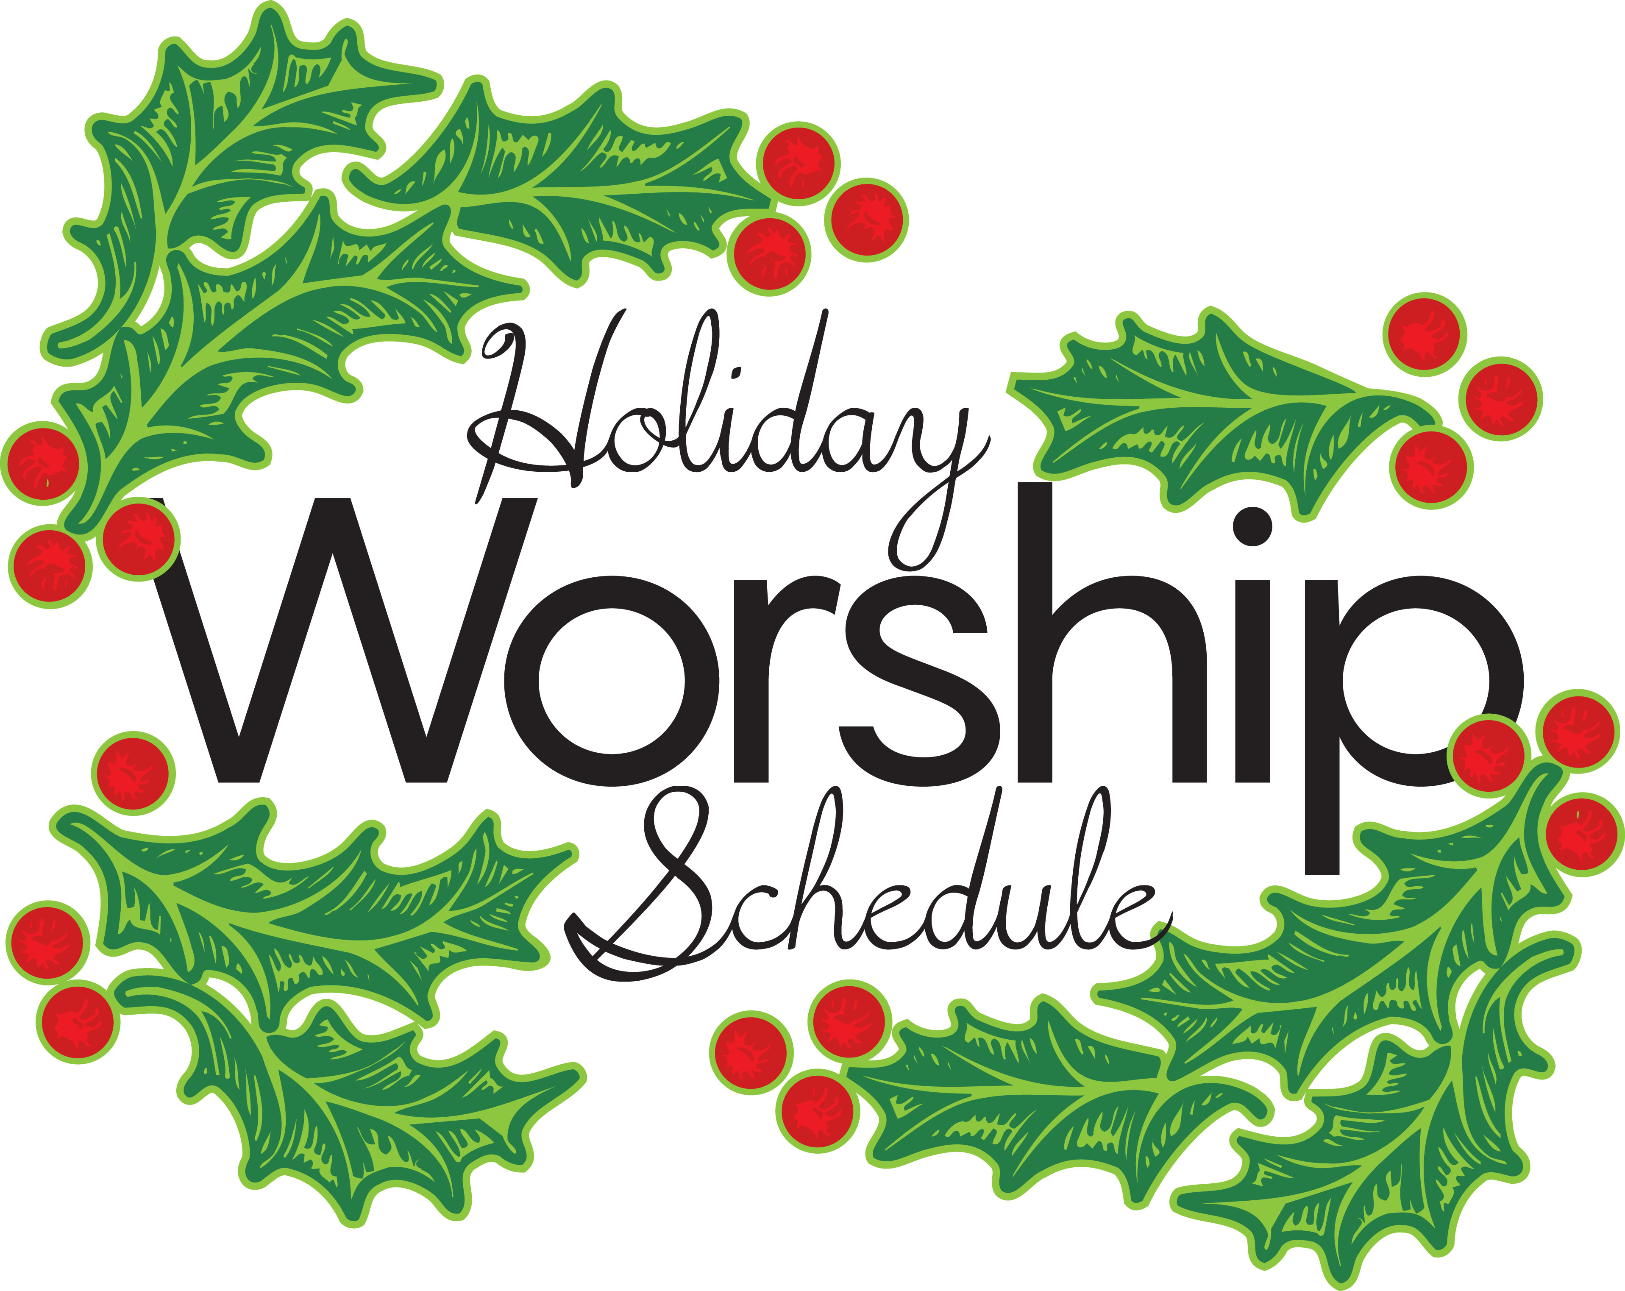

Advent Midweek Worship:
Wednesday, Dec. 9 – The King Welcomed – Psalm 118:25-29
Wednesday, Dec. 16 – The King Comes for Us – Isaiah 40:1-8

Christmas Week Worship:
Christmas Eve at 6:30 pm
Christmas Day at 9:00 am
Christmas Sunday, December 27, at 8 and 10:30 am
New Year’s Eve (with Holy Communion) at 6:30 pm

In the Narthex:
- Portals of Prayer, Meditations, Forward in Christ
- Advent Devotions written by Martin Luther College professors

- God’s Creation Calendars
Permission to reprint hymns in this service obtained from ONE LICENSE with license #A-716671. All rights reserved.

