

Midweek Advent ~ December 9, 2020

Opening Hymn – CW 29 v. 3
♫ Those dear tokens of his passion
Still his dazzling body bears,
Cause of endless exultation
To his ransomed worshipers.
With what wonder, with what wonder,
Gaze we on those glorious scars.

Invocation (sung)
Pastor: In the name of the Father...
Congregation: Alleluia! Alleluia!
Pastor: In the name of the Son…
Congregation: Alleluia! Alleluia!
P: In the name of the Spirit…
C: Alleluia and Amen!

Confession (sung)
P: We know that we are the reason you first came; Lord, have mercy.
C: Lord, have mercy.
P: In ignorance and in stubborn sin we had nailed you to the tree;
Christ, have mercy.
C: Christ, have mercy.
P: Prompted by your Spirit we acknowledge our sin and plead for your mercy; Lord, have mercy.
C: Lord, have mercy.

Absolution
P: Because of his great love for us, Christ has redeemed us.
As a fellow forgiven child of God, and called servant of Christ, I proclaim his grace to you. Rejoice in his salvation!
C: ♫ Alleluia! Alleluia! Jesus is our Lord and King!

Prayer of the Day
Pastor (sung psalm style):
When you rose, O Christ, the marks `of the cross
Remained as evidence of your `sac-ri-fice.
Though intended as symbols of hatred and `re-jec-tion,
They are the marks of your love and ac- `cep-tance.
We gaze upon them in joyful `won-der,
Seeing our sal- `va-tion.

Congregation sings:
Praise to you for you live and reign with the `Fa-ther
And the Holy Spirit, now and for- `e-ver.
Alleluia! Alleluia! Jesus is our Lord and King!
First Lesson Isaiah 49:5-7 (EHV)
5 And now the Lord says—he who formed me in the womb to be his servant to bring Jacob back to him and gather Israel to himself, for I am honored in the eyes of the Lord and my God has been my strength—
6 he says: “It is too small a thing for you to be my servant to restore the tribes of Jacob and bring back those of Israel I have kept. I will also make you a light for the Gentiles, that my salvation may reach to the ends of the earth.”
7 This is what the Lord says—the Redeemer and Holy One of Israel—to him who was despised and abhorred by the nation, to the servant of rulers: “Kings will see you and stand up, princes will see and bow down, because of the Lord, who is faithful, the Holy One of Israel, who has chosen you.”

Psalm of the Day – Psalm 24 (read responsively)
All: Let the Lord enter; he is the King of glory.

M: The earth is the Lord’s, and everything in it,
C: the world and all who live in it;

M: for he founded it upon the seas
C: and established it upon the waters.

M: Who may ascend the hill of the Lord?
C: Who may stand in his holy place?

M: He who has clean hands and a pure heart,
C: he will receive blessing from God his Savior.
All: Let the Lord enter; he is the King of glory.

M: Lift up your heads, O you gates;
Be lifted up, you ancient doors,
C: that the King of glory may come in.

M: Who is this King of glory?
C: The Lord strong and mighty,
the Lord mighty in battle.

M: Lift up your heads, O you gates;
Be lifted up, you ancient doors,
C: that the King of glory may come in.

M: Who is he, this King of glory?
C: The Lord Almighty--he is the King of glory.
All: Glory be to God the Father and to the Son
And to the Holy Spirit,
As it was in the beginning,
Is now, and will be forever. Amen.
Let the Lord enter; he is the King of glory.

Gospel Lesson Matthew 21:1-11 (EHV)
1 As they approached Jerusalem and came to Bethphage on the Mount of Olives, Jesus sent two disciples, 2 telling them, “Go to the village ahead of you. Immediately you will find a donkey tied there along with her colt. Untie them and bring them to me. 3 If anyone says anything to you, you are to say, ‘The Lord needs them,’ and he will send them at once.”
4 This took place to fulfill what was spoken through the prophet:
5 Tell the daughter of Zion: Look, your King comes to you, humble, and riding on a donkey, on a colt, the foal of a donkey.
6 The disciples went and did just as Jesus commanded them. 7 They brought the donkey and the colt, laid their outer clothing on them, and he sat on it. 8 A very large crowd spread their outer clothing on the road. Others were cutting branches from the trees and spreading them out on the road. 9 The crowds who went in front of him and those who followed kept shouting,

Hosanna to the Son of David!
Blessed is he who comes in the name of the Lord!
Hosanna in the highest!
10 When he entered Jerusalem, the whole city was stirred up, asking, “Who is this?” 11 And the crowds were saying, “This is Jesus, the prophet from Nazareth in Galilee.”

Hymn - CW 19 v. 1,2,4
Sing: O Lord, how shall I meet you, How welcome you aright?
Your people long to greet you, My hope, my heart’s Delight.
O Jesus, let your Word be A lamp to light my way,
To show me how to please you, To guide me ev’ry day.

Meditate: Love caused your incarnation; Love brought you down to me.
Your thirst for my salvation Procured my liberty.
Oh, love beyond all telling That led you to embrace
In love, all love excelling, Our lost and fallen race!

Sing: Sin’s debt, that fearful burden, Let not your souls distress;
Your guilt the Lord will pardon And cover by his grace.
He comes, for you procuring The peace of sin forgiv’n,
His children thus securing A heritage in heav’n.

Text: Paul Gerhardt, 1607–76, abr.; tr. composite.

Sermon Psalm 118:25-29
25 O Lord, please save us now. O Lord, grant us success.
26 Blessed is he who comes in the name of the Lord. We bless you from the house of the Lord.
27 The Lord is God, and he makes light shine on us. Bind the festival with branches as far as the horns of the altar.
28 You are my God, and I will give you thanks. You are my God, and I will exalt you.
29 Give thanks to the Lord, for he is good, for his mercy endures forever.

The King: How Shall I Greet Him? How Welcome Him Aright?

Dear friends in Jesus: In a familiar Advent hymn, we sing: "Lift up your heads, you mighty gates”. Normally we don’t think of gates having heads, let alone that those heads would be downcast and then lifted up in joy. Neither would we think that the gates “be lifted up” or open themselves to welcome the Christ.
Now, poetry is one thing. A lot of things are expressed in poetry that don’t happen in normal life; things acting as humans. “My love is a river flowing straight to your heart.” Hymns are poetry so we expect a few out-of-the-ordinary expressions. But with these unusual word combinations, the power of the emotion or the thought is more strongly conveyed.
But actual inanimate objects acting like humans? Not only is it possible, but under God’s power, it may be necessary for non-living things to act. The Psalms declare: “The heavens tell about the glory of God. The expanse of the sky proclaims the work of his hands,” (19:1). At his Palm Sunday arrival in Jerusalem, people joyfully greeted him as God. To which “some of the Pharisees from the crowd said to him, ‘Teacher, rebuke your disciples!’ He replied, ‘I tell you, if these people would be silent, the stones would cry out’,” (Luke 19:39,40). In order that God be properly praised, things may have to shout his glory.
If gates will open themselves for Christ, and rocks will cry out his praises, what about the humans who have real voices and real living bodies with which to act? How shall I greet him? With hosannas for the Savior, with thanks for the King.
This psalm text finds fulfillment in Palm Sunday’s joyful parade. In English, the first words are “Lord, please save us now.” That very phrase is in the Hebrew word, “Hosanna!” What are they shouting as Jesus comes to town? “Lord, do your great work. Save us!” While they may not have anticipated the blood-stained cross as the means to save, they certainly wanted the work to be done.
They were excited that it should take place and could be confident that it would be done exactly according to God’s will. Their words express their certainty. “Blessed is he who comes in the name of the Lord.” God’s own chosen one, who comes in his name, would do the thing right! Jesus was coming to Jerusalem to make it all work.
The first step is a procession to the altar.
Here we find a challenge in translation. Not all words move easily from one language to another. Sometimes, the best we can do is a fairly awkward expression in the new language that never quite expresses the original perfectly. So it is, in verse 27, the English phrase is “Bind the festival with branches as far as the horns of the altar.” Poetry or not, that’s hard to make sense of.
The editors of the Evangelical Heritage Version have a longer footnote to that phrase, explaining why it comes across that way. In the footnote, they offer an alternate phrasing that makes a lot more sense, and in fact, fits the Palm Sunday event more precisely.
Here’s the alternate: “It’s the festival! Decorate the route with boughs and march in a procession towards the horns of the altar.” The Passover festival was this week! Did not the crowds decorate the route with boughs and branches? Where was Jesus headed? He went directly to the temple, where the altar stood.
Why there? Christ was coming as the perfect substitute for all the animals who shed their blood for the people’s forgiveness. This moment in the temple was a graphic visual of the transfer of the task to Jesus himself.
But importantly, Christ came to cleanse the temple and purify the altar for its proper purpose. When he arrived, “Jesus entered the temple courts and drove out all those who were selling and buying in the temple. He overturned the tables of the money changers and the seats of those who were selling doves,” (Matthew 21:12). The transfer from one altar to the next would take place later in the week. For now, at least, the old sacrifices ought to be done with respect and sincerity. Jesus made sure that could happen.
On Friday there would be another procession to another altar. Not as big of a crowd, and no decorations on the way to Calvary, but a very vital procession nonetheless. This time, a few soldiers, Jesus and a couple criminals comprised the parade. But there at Golgotha’s altar of the cross, Christ would offer his blood as the ultimate payment for sin, proving beyond all doubt that he “loves us and has freed us from our sins by his own blood,” (Revelation 1:5).
As they nailed Jesus to the tree, the soldiers ensured that God’s will was done, that his Son would pay the price God’s law demanded of us. The soldiers thought they were doing the will of Pontius Pilate; that they were demonstrating Rome’s power over Jewish upstarts. But as was said several weeks ago, this is a king who conquers by being conquered.
“Save us now!”? He certainly did! St. John boldly announces, “The blood of Jesus Christ, his Son, cleanses us from all sin,” (I John 1:7).
But there’s one more procession—and not the one from the cross to the tomb. When Christ comes again, we’ll be shouting out once more, “Blessed is he who comes in the name of the Lord!” With his angels attending him, Christ Jesus will parade into town to collect his believing saints to live in glory forever.
Let’s not make the rocks do the praising! Today’s psalmist encourages: “You are my God, and I will give you thanks. You are my God, and I will exalt you.” Let it be me, he who has been saved, not stones which have no soul to be redeemed. Let it be us, we who enter the gates of heaven, not the gates which have no heart. Let it be me who cries, “Hosanna!”
“Give thanks to the Lord,” the psalmist urges, “for he is good, for his mercy endures forever.” This king is worthy of “Hosannas” and “Blesseds” for he is good.
“Good” is a fairly generic term. What I consider “good” and what you think is “good” may be very different. But let’s look at what distinguishes this king from other kings to see his goodness.
He is a king who brings gifts to his people. Unlike the monarch who taxed the peasants for his own benefit, this king reverses the process. Instead of taking money from the poor to support his wars, or his luxurious clothing, or his indulgent feasts, this king “has distributed freely; he has given to the poor,” (Psalm 112:9 ESV). Rather than taking from others, Paul speaks confidently, “My God will fully supply your every need, according to his glorious riches in Christ Jesus,” (Philippians 4:19). He’s got the whole world in his hands, and he gives generously from that world to his subjects.
Paul rejoiced in that. Even though St. Paul knew rough days and even days without food—and was content in them—speaking to the Philippians he thanks them that through their support God brought Paul his needs. In fact, Paul discouraged further gifts, “I am not saying this because I lack anything,” instead, “I can do all things through Christ, who strengthens me,” (4:11,13). God was good to him. St. Paul saw it and was uplifted by it.
Have we not seen in this fall’s harvest season God’s goodness? Our stores are full, our pantries have plenty. If that is not so, please give us a chance to help, for this king works through his believing people. We are blessed with sufficient supplies for life. He is good! What a praiseworthy king, deserving of our thanks!
He is a king with mercy. Through Lewis Carrol’s work, Alice in Wonderland,” we are familiar with the monarch’s cry, “Off with her head!” Though a fictional work, such cavalier attitude was well understood. More than one monarch had servants killed for minor offenses—even as little as being rumpled in their dress or hair. Courtiers were executed for perceived disobedience without investigation or trial. That’s why England defined its allowances of kingly behavior in the Magna Carta. In part, that’s why America rebelled. Mercy was not the hallmark of the self-absorbed, monarch.
So greatly different was Christ, who in mercy lived in a humble state; born in the stable and raised in Nazareth of all places! Jesus, who in mercy trod through life without retainers or carriages but moved about on foot without servant or home. Christ, who in mercy fed the hungry and healed the sick, even when he needed rest. Jesus, who in mercy pleaded for the soldiers that God forgive them.
But, of course, Christ, in the greatest of mercy, sent himself to the defeat of the cross and the dungeons of hell to win and then proclaim victory over sin, death, hell and Satan, at great personal cost. As many have said over the years: “Nails couldn’t hold Jesus to the cross; love and mercy did.”
How shall I greet him? “You are my God, and I will give you thanks.”
What shall my thanks be? By all means, worship with joyful hearts and loud praises to Christ the King! I pray that we find you here in the sanctuary or on our Facebook page throughout the season of Advent and Christmas. Some of you at home have mentioned that you feel free to belt out those hymns, though your voice isn’t great, ‘cause it’s not so embarrassing in the privacy of your living room. But here or elsewhere, lift up your voice with strength! And may God give you the time, carved out among all the other pressures of the season, to fit in some or all of the special services hosted by Our Savior’s. “You are my God, and I will exalt you.”
How else will our thanks be known? We take door offerings for special circumstances. There are opportunities in the community that benefit those in need: Toys for tots; Coats for Kids; and many others. And there are some not tied to the season—just throwing one out there like the American Cancer Society—who need funding throughout the year. Consider that Christ says, “Whatever you do for the least of these brothers of mine, you do for me.” That’s a thank you gift to Jesus. “Give thanks to the Lord, for he is good, his mercy endures forever.”
That’s how to greet him! I kinda wish I had been there for Palm Sunday to welcome Christ. But I fear that I would have been one to turn my back on Good Friday. But I wasn’t there. I’m here. So, whatever the circumstances today, I sure don’t want that the gates have to open themselves, or the stones have to cry out in my place. Let us proclaim: “Blessed is he who comes in the name of the Lord. Hosanna in the highest.” AMEN.

Prayers
M: Eternal Father, throughout the centuries you repeated and affirmed your promise to send the offspring of the woman to crush the serpent’s head. We praise you that you have fulfilled that promise in bringing your Son, Jesus Christ, to this world to destroy the works of the devil.
As we prepare to celebrate the birth of our King, use your mighty Word to shatter our pride and to rouse us from our spiritual slumber and apathy. Move us to take to heart the Baptist’s admonition: “Repent, for the kingdom of heaven is near.
Let the good news of your Son be our joy and strength. Use it to cheer the lonely, encourage the fearful, and give hope to the despairing. In these days before Christmas, spare us from the stress of deadline and the frenzy of commercialism. Fill our lives with the message of your peace and the music of your grace.
Direct our eyes not only to the manger but also to the skies, where we will see your Son coming again, not as a lowly child but as the Lord of lords. Lift up our hearts in joyful anticipation of that day.
Special prayers and intercessions may follow

Come quickly, Lord Jesus, in your grace, in your power, and in your glory. Come, Lord Jesus, come! Amen.

Closing Hymn - CW 1 v. 1-3
♫ The advent of our King
Our prayers must now employ,
And we must hymns of welcome sing
In strains of holy joy.

♫ The everlasting Son
Incarnate deigns to be,
Himself a servant’s form puts on
To set his servants free.

♫ O Zion’s Daughter, rise
To meet your lowly King,
Nor let a faithless heart despise
The peace he comes to bring.
Text: Charles Coffin, 1676–1749; tr. John Chandler, 1806–76, alt.

_________________________________________________________________________

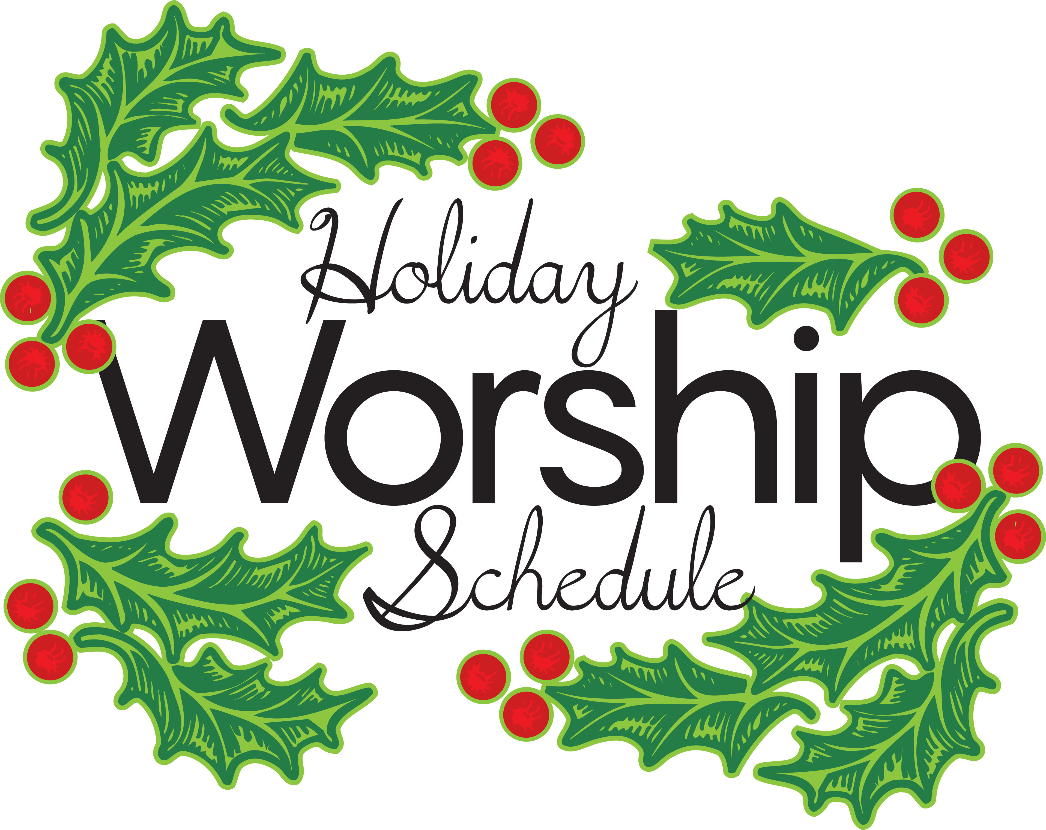
Advent Midweek Worship:
Wednesday, Dec. 9 – The King Welcomed – Psalm 118:25-29
Wednesday, Dec. 16 – The King Comes for Us – Isaiah 40:1-8

Christmas Week Worship:
Christmas Eve at 6:30 pm
Christmas Day at 9:00 am
Christmas Sunday, December 27, at 8 and 10:30 am
New Year’s Eve (with Holy Communion) at 6:30 pm


Permission to reprint hymns in this service obtained from ONE LICENSE with license #A-716671. All rights reserved.

